ADP GlobalView®

Master Data Requirements: Vietnam

Commercial in Confidence

|  |  |
| --- | --- |
| Author | Qi Wang |
| Document Reference | GV00004681 |
| Date | 2020-03-26 |
| Version | 1.3 |

##### Copyright and Confidentiality

Copyright © 2008, 2011, 2012, 2016 ADP, LLC. ADP Proprietary and Confidential - All Rights Reserved. For Internal Use Only. These materials may not be reproduced in any format without the express written permission of ADP, LLC. This document must be kept strictly confidential at all times. It must not be disclosed to any person without the prior written consent of ADP, LLC.

ADP provides this publication "as is" without warranty of any kind, either express or implied, including, but not limited to, the implied warranties of merchantability or fitness for a particular purpose. ADP is not responsible for any technical inaccuracies or typographical errors which may be contained in this publication. Changes are periodically made to the information herein, and such changes will be incorporated in new editions of this publication. ADP may make improvements and/or changes in the product and/or the programs described in this publication at any time without notice.

The ADP® logo and ADP® letters are registered trademarks of ADP, LLC. GlobalView® is a registered trademark of ADP, LLC. iLearn@ADP® is a registered trademark of ADP, LLC. In the Business of Your Success(SM) is a service mark of ADP, LLC.

**Third-Party Trademarks**

Adobe® is a registered trademark and Acrobat(TM) is a trademark of Adobe Systems Incorporated.

Microsoft®, Windows®, Internet Explorer®, Word®, and Excel® are registered trademarks of Microsoft Corporation.

SAP® and SAP® R/3® are registered trademarks of SAP AG in Germany and in several other countries.

All other trademarks and service marks are the property of their respective owners.

##### Release Notice

This document applies to the ECC6 SAP R/3 version of the GlobalView® product solution. It is valid for ECC6-upgraded projects as well as new implementations done on the ECC6 template. It includes documentation of template enhancements from January 2011 and forward. Check the Document Attributes panel for reference to the ECC5 version.

##### Authorizations and Amendments History

| Version | Authored | Approved | CRM Ticket | Next Review Date |
| --- | --- | --- | --- | --- |
| 0.1 | Qi Wang |  |  |  |
| 0.2 | Qi Wang |  | Aligned with AU version and added data sequence information |  |
| 1.0 | Qi Wang |  | Update IDL table |  |
| 1.1 | Qi Wang |  |  |  |
| 1.2 | Bre Dawson |  |  |  |
| 1.4 | Bre & Qi |  | Update IDL table for P2 and P3 |  |

##### Table of Contents

Common Infotypes 6

Initial Data Load 6

Actions - Infotype 0000 <Mandatory Infotype> 7

Organisational Assignment - Infotype 0001 <Mandatory Infotype> 8

Personal Data - Infotype 0002 <Mandatory Infotype> 9

Addresses - Infotype 0006 <Mandatory Infotype> 11

Planned Working Time - Infotype 0007 <Mandatory Infotype> 12

Basic Pay - Infotype 0008 <Mandatory Infotype> 13

Bank Details - Infotype 0009 <Mandatory Infotype> 14

Permanent Allowances and Deductions/Temporary Allowances and Deductions Infotype 0014 and 0015 16

IT0014 16

IT0015 17

Family Member / Dependents - Infotype 0021 18

Personal ID - Infotype 0105 <Mandatory Infotype> 19

Personal ID - Infotype 0185 <Mandatory Infotype> 20

Absence Quotas - Infotype 2006 21

Quota Corrections - Infotype 2013 22

Absences - Infotype 2001 23

Employee Remuneration Information - Infotype 2010 24

Country Specific Infotypes 25

Change Personal Income Tax - Infotype 9520 <Mandatory Infotype> 25

Change Social Insurance Vietnam - Infotype 9521 <Mandatory Infotype> 26

Compulsory Insurance 26

Voluntary Insurance 27

Unemployment Insurance 28

Health Insurance 29

Annual Values for Tax and Reporting - Infotype 9524 30

# Common Infotypes

Generally infotypes 0000, 0001, 0002 and 0006 come through the interface, and sometimes others (this can be client dependent). However this data needs to be loaded at the beginning of an implementation at which stage the interface is not switched on.

Below is a list of all the infotypes required. When completing the spreadsheets check the notes in the column heading. This will help you to provide the right information. Do not provide data where the note says leave blank.

See below:

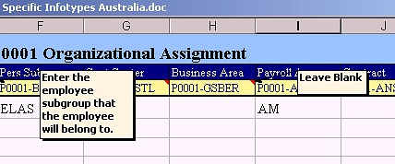

### Initial Data Load

The Initial data load sheet must be loaded before any other sheet. It holds infotype 0000, 0001, 0002 and 0041 information combined. The infotypes hold the following information:

# Master Data – Introduction

GlobalView® categorizes data types according to the following table –

| **Data Type** | **Data Set** | **Description** | **Meaning** |
| --- | --- | --- | --- |
| Infotype | P0000–P0999 | Payroll Infotypes | Infotypes required to process payroll  e.g. P0002 Personal Data, P0006 Addresses etc. |
| Infotype | P2000–P2020 | Basic Time Infotypes | Infotypes containing time events e.g. P2001 Absences, 2002 Attendances, 2003 Substitutions etc. |
| Other Master Data | BNKMD | Bank Keys | Bank-State-Branch numbers, bank names |
| Other Master Data | CCRMD | Cost Centres | Organisational Cost Centre codes |
| Other Master Data | MGRLK | WBS Element | WBS Element |
| Other Master Data | HROBJ | HR Objects | Position descriptions |
| New Hire | NHIRE | New Hire | Composite spreadsheet containing all the values required to create an Employee ID in the system |

### ADP Spreadsheet Loader

ADP Spreadsheet Loader (SSL) is used to format data for loading into GlobalView®.

This document assumes familiarity with ADP Spreadsheet Loader (SSL) – refer to Appendix for detailed SSL End User Guides.

When completing the Upload Spreadsheets, check the notes in the column headings which will assist with entering the information correctly. Do not provide data where the note says leave blank. Red-lined cells indicate mandatory fields which must contain an entry.

SSL can be used for Master Data infotypes, Other Master Data, and transactional data.

Any of the Infotypes and Other Master Data types required may be selected for inclusion in an ADP SSL Workbook. Each data type is contained in a single worksheet as shown in the tabs at the bottom of the workbook –

### Time Constraint Rules

To maintain data integrity and prevent duplication of records every Infotype belongs to a Time Constraint class, which will determine whether a record must exist in the system at all times, whether multiple instances of the record can exist, and so on.

The following table provides a summary of Time Constraints –

| **Time Constraint** | **Rule** | **Includes** | **Examples** |
| --- | --- | --- | --- |
| 1 | Record must exist with no gaps, no overlaps | P0002 (Name) | Employee must always have a name record and can only have one name record |
| 2 | Record may include gaps but no overlaps | P2001 (Absence) | Employee does not have to be on leave but if on leave cannot be on more than one kind |
| 3 | Record may include gaps, and may overlap | P0009 (Bank Account) | Employee can have a number of secondary bank accounts and they may co-exist |

Refer to SSL End User Guides in the Appendix for detailed explanation.

### Relationship between Infotypes and Records

Infotypes are screens which gather data fields into logical groups. Records are created and maintained by the entry of data into Infotype screens. However records are different to infotypes.

A record is created when a start date is entered in an Infotype, either directly or via SSL.

Infotypes are screens which gather data fields into logical groups. Records are created and maintained by the entry of data into Infotype screens. However records are different to infotypes.

A record is created when a start date is entered in an Infotype, either directly or via SSL.

This record has a beginning date of 02.02.2005 and continues indefinitely –



When a new record is created, say in the event of a name change, the End Date of the existing record is changed to the day before the new record’s Start Date. In other words the record is ‘delimited’ (if Time Constraint 1) –



Then the current record will start from the new date and continue indefinitely –



In overview, the records will look like this –

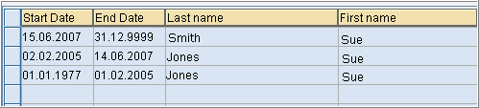

### Data Upload Sequence

During GlobalView® implementation, the sequence in which Infotypes and Other Master data types are uploaded is important. This is because certain values must be present in the system in order for records to be created.

**Upload Guidelines –**

* Cost Centre master data (CCRMD) must exist in the system prior to employee’s Organisational Assignment (P0001) being created if Cost Centre is to be assigned to an employee
* Bank Key master data (BNKMD) must be loaded before account information can be associated with an employee in Bank Detail (P0009)
* Creation of an Employee ID always requires a minimum of Infotypes 0000 (Actions), 0001 (Org. Assignment), 0002 (Personal Data), and 0041 (Date Specifications). The NHIRE worksheet is used to create new Employee IDs, as it contains all of these required entries

Different countries have different Master Data requirements – while the general guidelines are the same, the particulars for each country may vary.

# RMIT VN Data Conversion

### Initial Data Conversion

For RMIT Vietnam, it is expected that all initial data conversion will be performed using one time SSL uploads (refer to Appendix for SSL templates). Any changes following Go-Live will then be managed by a combination of integration from SAP HR system and SSL uploads.

The expected SSL load sequence should be as per below –

| **Data Seq.** | **Object / Infotype** | **Description** | **Method** | **Note** |
| --- | --- | --- | --- | --- |
| 1 | BNKMD | Bank Master Data | SSL | Bank Keys |
| 1 | WBSEL | WBS Elements | SSL | WBS Elements |
| 2 | CCRMD | Cost Centre Master Data | IDL | Cost Centers |
| 2 | HROBJ | Position Master Data | IDL | Positions |
| 2 | NHIRE | NHIRE Employee Hire | IDL | Employee Hire – includes P0000 Actions, P0001 Org Assignment, P0002 Personal Details, P0041 Date Specifications, P0709 Global ID (automatically loaded) |
| 2 | P0006 | Address Infotype | IDL | Address details |
| 2 | P0007 | Planned Working Time Infotype | IDL | Work schedule details |
| 2 | P0008 | Basic Pay Infotype | IDL | Salary details |
| 2 | P0009 | Bank Details Infotype | IDL | Bank details |
| 2 | P0014 | Recurring Payment Infotype | IDL | Recurring Allowances Payment |
| 2 | P0027 | Cost Distribution Infotype | IDL | Cost distribution overrides |
| 2 | P0105 | Communications Infotype | IDL | Email, user ID |
| 3 | P9520 | Personal Income Tax | SSL | Personal Income Tax |
| 3 | P2006 | Absence Quota | SSL | Absence quota shell |
| 3 | P2012 | Time Transfer Specifications | SSL | Time Override flags |
| 3 | P9521 | Social Insurance | SSL | Social Insurance |
| 3 | P9522 (P0021) | Additional information (Family Dependents) | SSL | Additional information (Family Dependents) |
| 4 | RPUTRBK0 | Update Control Record | - | Time & Payroll retro accounting dates updated to reflect go-live date |
| 4 | RPTIME00 | Run Time Evaluation (1 day) | - | Create absence quota records to 31.12.9999 |
| 5 | P2013 | Quota Corrections | SSL | Leave balances (AL, SL, LSL, TIL) |
| 6 | RPTIME00 | Run Time Evaluation (1st Period) | - | Update quotas with leave balances |
| 7 | T558D&B | Payroll Account Transfer | PTD/ YTD  SSL | YTD payroll data for tax and average calculations |
| 8 | /EPIUSE/HVNCALC0 | Run YTD Payroll | - | Create YTD payroll results |
| 9 | P0014 | Recurring Payment Infotype | SSL | Recurring Allowances Payment not covered by PECI |
| 9 | P0015 | Additional Payment | SSL | Additional Payment |
| 9 | P9524 | Annual Values for Tax - V | SSL | Annual Values for Tax - V |
| 10 | RPUTRBK0 | Update Control Record | - | Time retro accounting dates updated to reflect go-live date |
| **GV Go-Live** | | | | |
| 11 | WD Transaction Data (PECI) |  | WD | Employee data loaded into IT0015 (Additional Payments), |
| 11 | WD G2 |  | WD | IT2002 (Attendances), IT2001 (Absences), IT2003 (Substitutions) |
| **Parallel 1 Transactional Data** | | | | |
| 12 | P0015 | Additional Payments | SSL | For parallel testing only |
| 12 | P0014 | Additional Payments | SSL | For parallel testing only |
| 12 | P0416 | Time Quota Compensation | SSL | For parallel testing only |
| 12 | P2002 | Attendances | SSL | For parallel testing only |
| 12 | P2001 | Absence Data | SSL | For parallel testing only |
| 12 | P2003 | Substitution Data | SSL | For parallel testing only |
| **Parallel 2 & 3 Transactional Data** | | | | |
| 13 | NHIRE | NHIRE Employee Hire | SSL Transactional | If new hires require a new cost centre, WBS or Position to be created, please create via CCRMD, HROBJ, WBSEL within the SSL transactional template |
| 13 | P0000 | Terminations | SSL Transactional |  |
| 13 | P0001 | Organisational Changes | SSL Transactional | Only changes that will result in a change of pay. E.g. change from Perm to Casual |
| 13 | P0007 | Planned Working Time Infotype | SSL Transactional |  |
| 13 | P0008 | Basic Pay Infotype | SSL Transactional |  |
| 13 | P0014 | Recurring Payments/Deductions | SSL Transactional |  |
| 13 | P0015 | Additional Payments | SSL Transactional |  |
| 13 | P0416 | Quota compensation | SSL Transactional | Only payouts, not termination payments |
| 13 | P2010 | Employee Remuneration Info | SSL Transactional |  |
| 13 | P2002 | Attendances | SSL Transactional |  |
| 13 | P2001 | Absence Data | SSL Transactional |  |
| 13 | P2003 | Substitution Data | SSL Transactional |  |

### YTD Data

For RMIT Vietnam, the only historical payment data to be migrated will be data required to support payroll calculations. The below table outlines such data sets –

| **Data Set** | **Purpose** | **Data Conversion Requirement** |
| --- | --- | --- |
|  |  |  |
|  |  |  |
|  |  |  |
|  |  |  |
|  |  |  |
|  |  |  |
|  |  |  |

### Pre Go-Live Payments

Any payments required to be made to an employee for a period prior to GlobalView® Go-Live (eg. retro adjustment) will be required to be entered via Infotype 0015 gross, net or tax adjustment wage types in the first Go-Live pay period. This includes any overtime, leave, termination calculations, etc.

Refer to the tab page <Go-live Transfer WTs> in BPCW document for details.

### Data Mapping

Legacy to GlobalView® data mapping tables should be created for all configuration values (eg. wage types, personnel areas, personnel subareas, pay scale structures, tax scales etc) in order to populate the SSL data load templates. The GlobalView® values can be sourced from a combination of Configuration Worksheet, Payroll Blueprint word document or the G2 specification. Links to all documents are contained in the Appendix.

The data mapping for the Parallel Payroll cycles should contain mapping for transactional data (eg. absences, employee movements, new hires, termination, additional payments, time based payments, etc) which will not be required at Go-Live.

### Time Data Requirements

The below details RMIT specific data migration requirements in relation to time infotypes. Some of these will only be required to be migrated as part of parallel run testing only and have been noted as such, the remaining infotypes are required for parallel run testing as well as for Go-Live.

Further details of the requirements have been details in the [Time Blueprint](https://portal221.globalview.adp.com/irj/servlet/prt/portal/prtroot/com.sap.km.cm.navigation/room_extensions/cm_stores/ADP_Project_Documents/workspaces/00ceb2b3-6880-3710-78ab-a348abb83048/B.%20Blueprint/BP%20Documents?StartUri=/room_extensions/cm_stores/ADP_Project_Documents/workspaces/00ceb2b3-6880-3710-78ab-a348abb83048), please refer to this as required.

**IT0041 – Date Specifications**

The below are the date types which should be included in the migration and who they are required for –

| **Data Type**  **DAR01 - DAR04** | **Date Type text** | **Date to be Loaded**  **DAT01 - DAT04** | **Purpose** |
| --- | --- | --- | --- |
| 01 | Country Hire Date | Hire Date | Employee’s most recent hire / re-hire date  To be loaded for all employees |
| 02 | Company Hire Date | Hire Date | Employee’s original hire date (should only vary from 01 in cases of re-hire)  To be loaded for all employees |
| ;L | VN-LSL Annivers.Date | Anniversary Date -1 | Employee’s LSL service date  To be loaded for all employees except Casuals and Seasonal employees |

**IT0416 – Quota Compensation (parallel only)**

Quota compensation data is only required to be loaded for parallel run to reflect any employee who has requested a leave cash out during the parallel run periods. For Go-Live these requests will be manually entered into GV (there is no integration from Workday for this). This relates to in-service cash outs and should not be entered for terminations. The below is required –

* **Date of Cash Out:** Date of cash out payment to be entered, start and end date should be the same (BEGDA + ENDDA)
* **Compensation Method (QCTYP):** V001
* **Absence Quota Type (QTYPE):** Supported for 40 (Time Off in Lieu) only
* **Number (NUMBR):** Enter number of hours to be cashed out

**IT2001 – Absences (parallel only)**

Absence data is only required to be loaded for parallel run as for Go-Live this data will be sent to GV via the Time Off G2 supplemental integration where the absence entry is for the current period.

For parallel run, the below is required –

* **Time Off absences:** To reflect the Workday integration method, Time Off absences should be loaded on a daily basis. For full day absences, only the absence type (AWART + SUBTY), current day start and end date are required to be loaded (BEGDA + ENDDA). The daily hours will automatically default. For part day absences, as well as absence type, current day start and end dates the total number of hours (STDAZ) should be loaded.
* **Leave of Absence (LOA) absences:** To reflect the Workday integration method, LOA absences should be loaded reflective of the actual start date and end date of the leave duration. For employees without a defined return from leave date as yet, the end date should be loaded as 31.12.9999. Only absence type (AWART + SUBTY), actual start and end dates should be loaded (BEGDA + ENDDA), no hours.

Refer to the [Time Blueprint](https://portal221.globalview.adp.com/irj/servlet/prt/portal/prtroot/com.sap.km.cm.navigation/room_extensions/cm_stores/ADP_Project_Documents/workspaces/00ceb2b3-6880-3710-78ab-a348abb83048/B.%20Blueprint/BP%20Documents?StartUri=/room_extensions/cm_stores/ADP_Project_Documents/workspaces/00ceb2b3-6880-3710-78ab-a348abb83048) for list of GV absence codes to be used in the load files (AWART), mapping of this is held in Workday.

**IT2002 – Attendances (parallel only)**

Attendance data is only required to be loaded for parallel run as for Go-Live this data will be sent to GV via the Time Tracking G2 supplemental integration where the timesheet entry is for the current period.

For parallel run, each attendance record should contain the below –

* **Date of Timesheet entry:** Start date and end date should reflect the same date (BEGDA + ENDDA)
* **Type of Timesheet entry:** Attendance type as per BP (AWART + SUBTY)
* **Timesheet Value:** Depending on the type of timesheet entry, this will either be Total Hours (STDAZ), or Start Time and End Time (BEGUZ + ENDUZ). Refer to the BP for input method for each attendance type
* **Cost Assignment** – Where project costing is required, WBS (Position ID + Project Task) and Cost Centre fields should be loaded (POSID + KOSTL). Where project costing is not required, only Cost Centre field should be loaded (KOSTL). In both scenarios, Controlling Area (KOKRS) and Company Code (BUKRS) should also be populated.

Refer to the [Time Blueprint](https://portal221.globalview.adp.com/irj/servlet/prt/portal/prtroot/com.sap.km.cm.navigation/room_extensions/cm_stores/ADP_Project_Documents/workspaces/00ceb2b3-6880-3710-78ab-a348abb83048/B.%20Blueprint/BP%20Documents?StartUri=/room_extensions/cm_stores/ADP_Project_Documents/workspaces/00ceb2b3-6880-3710-78ab-a348abb83048) for list of GV attendance types to be used in the load files (AWART), mapping of this is held in Workday.

**IT2003 – Substitutions (parallel only)**

Substitution data is only required to be loaded for parallel run as for Go-Live this data will be sent to GV via the Substitution G2 supplemental integration where the ad hoc schedule data is for the current period.

For parallel run, each substitution record should contain the below –

* **Date of Substitution:** Start date and end date should reflect the same date (BEGDA + ENDDA)
* **Substitution Type:** Substitution Type (VTART) and Subtype (SUBTY) defaulted to ‘01’
* **Substitution Hours:** Start time and end time of the shift (BEGUZ + ENDUZ) as well as start time and end time of any breaks (PBEG1 + PEND1). In the case of a substitution for an OFF day, the Daily Work Schedule (TPROG) should be populated with value of ‘OFF’ instead

**IT2012 – Time Transfer Specifications**

Time Transfer specifications are required to support Long Service Leave calculations for Scheme 1 and Scheme 2. The below details the requirements for each –

**Long Service Leave Scheme 1**

Any employee with a hire date pre 1 June 2016 had a choice of whether they entered into Scheme 1 or Scheme 2. All employees will be defaulted into Scheme 2, and there will be an override flag on the employee’s record which should be used to identify any pre 1 June 2016 hires who elected to be in Scheme 1. This override flag should be setup in Infotype 2012 as per below –

* **Start Date (BEGDA):** Go-Live date (BEGDA)
* **End Date (ENDDA):** 31.12.9999 (ENDDA)
* **Time Transfer Type (ZTART):** 9LSL (LSL Scheme 1)
* **Hours (ANZHL):** 1

**Long Service Leave Scheme 2**

In addition to leave accrual, employees in Long Service Leave Scheme 2 are entitled to a cash payment at each 5 years of service milestone. This cash payment takes into consideration the employee’s workload percentage as well as any leave without pay taking during the 5 year period. In order to calculate this payment in GV, we need to know the number of days the employee has been active since their last 5 year milestone or hire date (whichever is most recent), their history of workload percentages since their last 5 year milestone or hire date (whichever is most recent) and their history of leave without pay days since their last 5 year milestone or hire date (whichever is most recent).

The below counters should be migrated to record this –

* ‘ZC10’ LSL S2 Wrkload chges in5y – Holds number of workload changes since last 5yr milestone (should reflect the value of the last ZZxx counter)
* ‘ZX00’ Total Workdays – Holds total work days since last 5yr milestone
* ‘ZX01-ZXxx’ Workdays – Holds work days for workload split since last 5yr milestone
* ‘ZY01-ZYxx’ LWOP – Holds LWOP days for workload split since last 5yr milestone
* ‘ZZ01-ZZxx’ Workload – Holds workload percentages since last 5yr milestone

For example, if the Go-Live Date was 01.01.2020 and an employee was hired on 15.07.2013 with the following service history –

| **Dates** | **# Cal. Days** | **Workload %** | **LWOP Days** |
| --- | --- | --- | --- |
| 15.07.2013 – 11.11.2014 | 484 | 100% | 10 |
| 11.11.2014 – 20.05.2016 | 556 | 80% | 2 |
| 20.05.2016 – 15.07.2018 | 786 | 90% | 0 |
| 15.07.2018 – 01.12.2018 | 139 | 60% | 2 |
| 01.12.2018 – 05.02.2019 | 66 | 80% | 0 |
| 05.02.2019 – 05.10.2019 | 242 | 60% | 2 |
| 05.10.2019 – 01.01.2020 | 88 | 100% | 1 |

The expected LSL Scheme 2 counters loaded should be –

| **Time Type** | **Hours** | **Note** |
| --- | --- | --- |
| ZC10 – LSL S2 Wrkload chges in5y | 4 | Aligns with the highest ZXxx counter (eg. ZX04 = 4) |
| ZX00 – Total Workdays | 535 | Total calendar days since the last 5 year anniversary (eg. from 15.07.2018 onwards) |
| ZX01 – Workdays | 139 | Calendar days in 1st workload split |
| ZX02 – Workdays | 66 | Calendar days in 2nd workload split |
| ZX03 – Workdays | 242 | Calendar days in 3rd workload split |
| ZX04 – Workdays | 88 | Calendar days in 4th workload split |
| ZY01 – LWOP | 2 | LWOP days in 1st workload split |
| ZY03 – LWOP | 2 | LWOP days in 3rd workload split |
| ZY04 – LWOP | 1 | LWOP days in 4th workload split |
| ZZ01 – Workload | 60 | Workload %’age during 1st split |
| ZZ02 – Workload | 80 | Workload %’age during 2nd split |
| ZZ03 – Workload | 60 | Workload %’age during 3rd split |
| ZZ04 – Workload | 100 | Workload %’age during 4th split |

How these different counters should be loaded is then as per below –

* **Start Date (BEGDA):** Go-Live date (BEGDA)
* **End Date (ENDDA):** Go-Live date (ENDDA)
* **Time Transfer Type (ZTART):** As per above table ‘Time Type’ field
* **Hours (ANZHL):** As per above table ‘Hours’ field

**IT2013 – Quota Compensation**

The below outlines how leave balance data should be migrated for each quota type.

**Time Off in Lieu –**

Leave balances should be loaded for all employees (except Casual and Seasonal) as per below –

* **Start Date (BEGDA):** Go-Live Date
* **Absence Quota Type (KTART):** 40
* **Quota Number (ACCNU):** Only one record is required which contains employee’s total leave balance up to and including the day prior to Go-Live date (minus any absence data). Leave balance number should be in hours.
* **Operation Indicator (ACCOP):** +
* **Transfer Type (ACCTR):** Y

**Annual Leave –**

Leave balances should be loaded for all employees (except Casual and Seasonal) as per below –

* **Start Date (BEGDA):** Go-Live Date
* **Absence Quota Type (KTART):** 50
* **Quota Number (ACCNU):** Only one record is required which contains employee’s total leave balance up to and including the day prior to Go-Live date (minus any absence data). Leave balance number should be in hours.
* **Operation Indicator (ACCOP):** +
* **Transfer Type (ACCTR):** Y

**Shadow Annual Leave –**

Leave balances should be loaded for all employees (except Casual and Seasonal) as per below –

* **Start Date (BEGDA):** Go-Live Date
* **Absence Quota Type (KTART):** 52
* **Quota Number (ACCNU):** Only one record is required which contains a calculation of the employee’s annual leave accrual from the last 1st January date prior to Go-Live up to and including the day prior to Go-Live date. This should not be reduced by 1 January) x (Entitlement Days x Average Daily Hours / Days in Year). If there has been a change in FTE throughout the period this should be factored into the calculation. Leave balance number should be in hours.
* **Operation Indicator (ACCOP):** +
* **Transfer Type (ACCTR):** Blank

**Sick Leave –**

Leave balances should be loaded for all employees (except Casual and Seasonal) as per below –

* **Start Date (BEGDA):** Go-Live Date
* **Absence Quota Type (KTART):** 60
* **Quota Number (ACCNU):** Only one record is required which contains employee’s total leave balance up to and including the day prior to Go-Live date (minus any absence data). Leave balance number should be in hours.
* **Operation Indicator (ACCOP):** +
* **Transfer Type (ACCTR):** Y

**Shadow Sick Leave –**

Leave balances should be loaded for all employees (except Casual and Seasonal) as per below –

* **Start Date (BEGDA):** Go-Live Date
* **Absence Quota Type (KTART):** 62
* **Quota Number (ACCNU):** Only one record is required which contains a calculation of the employee’s annual leave accrual from the last 1st January date prior to Go-Live up to and including the day prior to Go-Live date. This should not be reduced by 1 January) x (Entitlement Days x Average Daily Hours / Days in Year). If there has been a change in FTE throughout the period this should be factored into the calculation. Leave balance number should be in hours.
* **Operation Indicator (ACCOP):** +
* **Transfer Type (ACCTR):** Blank

**Long Service Leave Scheme 1 –**

Leave balances should be loaded for all employees who have been flagged as entitled to LSL Scheme 1 via Infotype 2012 ‘9LSL’, however there are variances based on the employee’s eligible years of service.

Employee with less than 10yrs of service –

* **Start Date (BEGDA):** Go-Live Date
* **Absence Quota Type (KTART):** 71
* **Quota Number (ACCNU):** Only one record is required which contains the employee’s pro-rata leave accrual balance from their hire date up to and including the day prior to Go-Live date. This pro-rata balance should be based on Entitlement / 10 years x Average Daily Hours / Days in Year. This should take into consideration workload changes for the employee as well as being reduced for leave without pay during this time. Leave balance number should be in hours.
* **Operation Indicator (ACCOP):** +
* **Transfer Type (ACCTR):** Blank

Employee with 10yrs of service or greater –

* **Start Date (BEGDA):** Go-Live Date
* **Absence Quota Type (KTART):** 71
* **Quota Number (ACCNU):** Only one record is required which contains the employee’s 25 day leave entitlement minus any absence data. Leave balance number should be in hours.
* **Operation Indicator (ACCOP):** +
* **Transfer Type (ACCTR):** Y

**Long Service Leave Scheme 2 –**

Leave balances should be loaded for all employees except (Casual, Seasonal and LSL Scheme 1 employees).

* **Start Date (BEGDA):** Go-Live Date
* **Absence Quota Type (KTART):** 72
* **Quota Number (ACCNU):** Two records should be loaded – First record should contain the employee’s pro-rata leave accrual balance from their last 5yr anniversary milestone prior to Go-Live date up to and including the day prior to Go-Live date. This pro-rata balance should be based on Entitlement / 5 years x Average Daily Hours / Days in Year. This should take into consideration workload changes for the employee as well as being reduced for leave without pay during this time.

The second record should contain the employee’s leave entitlement balance which will be the entitlement granted at the last 5yr anniversary milestone prior to Go-Live minus any absence data. If this milestone was greater than 12mths ago then the entitlement would have expired and therefore nothing should be migrated.

Leave balance numbers should be in hours.

* **Operation Indicator (ACCOP):** Both accrual and entitlement records should be loaded as ‘+’
* **Transfer Type (ACCTR):** Accrual records should be loaded as ‘blank’; Entitlement records should be loaded as ‘Y’

# Infotype Overview – General

## Actions - Infotype 0000 <Mandatory Infotype>

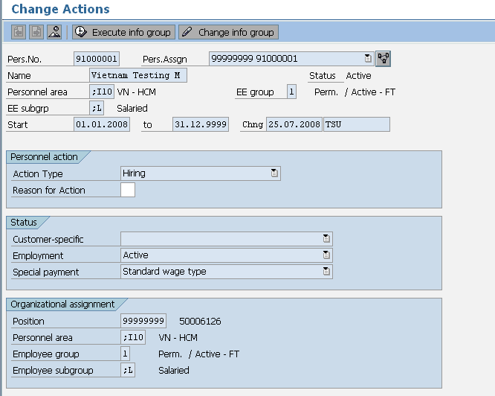

These are the mandatory fields

**Description**: All employees must hold an action infotype. It indicates if they are active or terminated and a new record is created when the action type (e.g. hire, transfer, termination) changes.

* Employment Status
* Personnel Area
* Employee group
* Employee subgroup information.

## Organisational Assignment - Infotype 0001 <Mandatory Infotype>

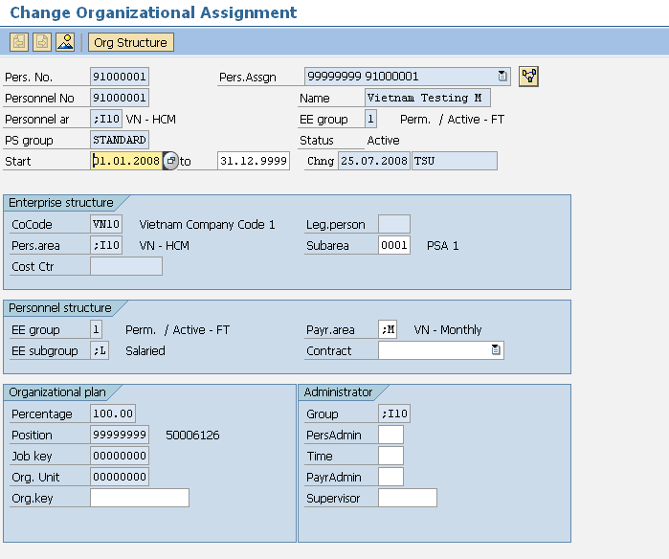

These are the mandatory fields for data load

**Description**: This holds all organisational information such as, company, location, department etc

* Personnel Area – Company Code
* Personnel Sub Area – Location
* Employee Group – Type of worker (e.g. Full-time Exempt)
* Employee Subgroup – Employment Band
* Cost centre
* Payroll Area
* Some clients may store additional info in this infotype

## Personal Data - Infotype 0002 <Mandatory Infotype>

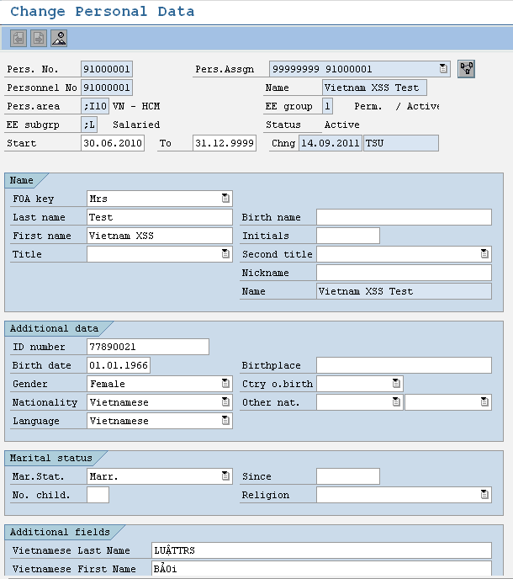

**Description**: This holds personal information relating to the employee.

* Form of Address
* Last Name
* First Name
* Gender
* Nationality
* Birth Date
* Marital Status
* Personal ID number
* Vietnamese Last Name
* Vietnamese First Name
* You also have the option of storing additional details if required

Note that IT0001 and IT0002 can be reloaded separately if necessary. Below are the relevant individual spreadsheets. These are not required to be completed for the initial load. They are for future changes.

## Addresses - Infotype 0006 <Mandatory Infotype>

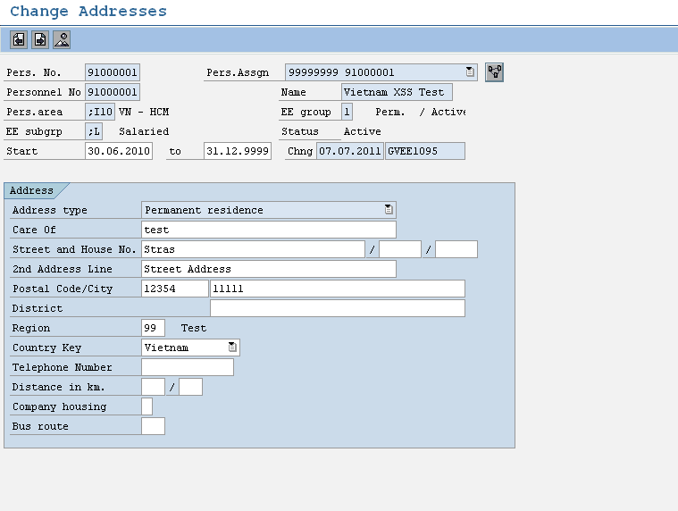

**Description**: Addresses Infotype 0006 subtype 0003 data load sheet stores details of employee’s address. Employees may have more than one address type (i.e. Permanent Residence and Postal address). Creating an additional address record for that employee in the data load sheet allows for this. The important fields are:

**Addresses – Infotype 0006:**

* Address Type (Each employee must have Address Type 3 – other subtypes are optional)
* House Number/Street
* Postal Code – Four Digits
* City/District
* State
* Country

## Planned Working Time - Infotype 0007 <Mandatory Infotype>

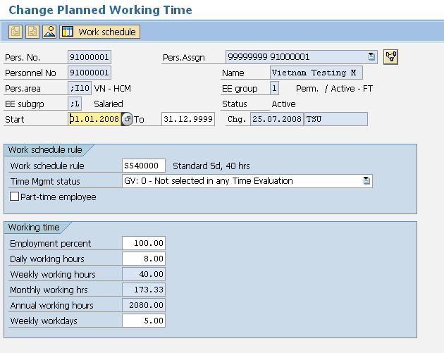

This is the only field you need to maintain. The other fields are populated from the work schedule rule

**Description:** Infotype 0007 holds employee work schedule information. The work schedule rule defines the hours worked. There will be a different rule for each country. There may be many more than one work schedule rule available in each country.

**Infotype 0007 loads the following information:**

* Work Schedule Rule
* Employee Time Management
* Part-Time Employee status

NB. If you are interfacing IT0000, IT0001 and IT0002 then IT0007 will be automatically created. If there are multiple work schedule rules then you need to supply IT0007 since the interface can only create one work schedule per country.

## Basic Pay - Infotype 0008 <Mandatory Infotype>

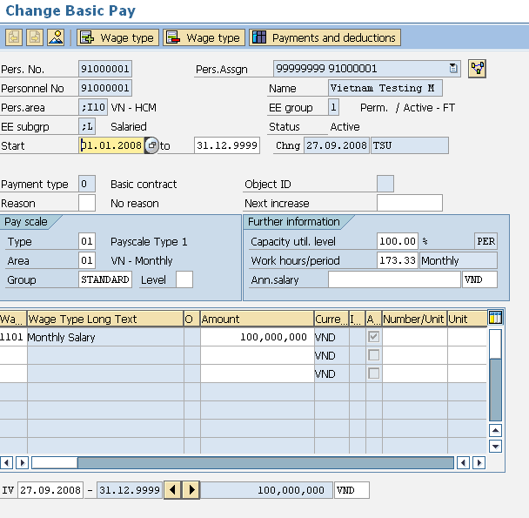

These are the mandatory fields. Note that the wagetypes for salary packages will vary depending on the client.

**Description**: This Infotype stores information about an employee’s salary and salary package. Additional Payments and Deductions are a separate Infotype. Infotype 0008 loads the following information:

**Basic Pay – Infotype 0008:**

* The Employee’s Annual Salary
* The Employee’s Monthly Salary
* Additional Salary Package wage types if applicable
* Hourly rates if applicable

## Bank Details - Infotype 0009 <Mandatory Infotype>

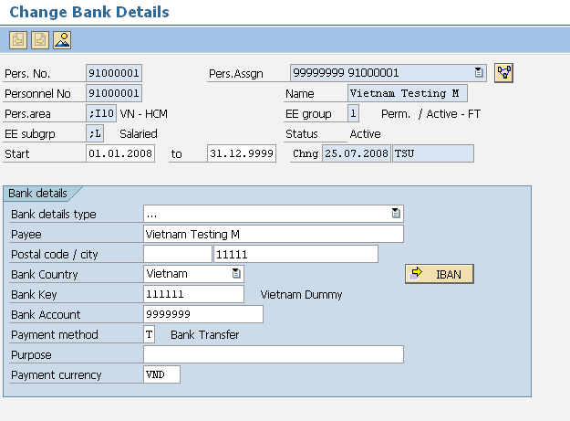

**Description**: This infotype holds details of the employee’s main bank account; an employee may have more than one bank details record. Additional banks hold the same details as the main bank but are entered through either an additional IT0009 record (in which case the money will come out of EVERY pay including off cycles) with a standard value or percentage or through an infotype 0011 record which works exactly like a deduction and will only come out of the main pay not an off cycle. Only employees with Payment method T will appear on the bank tape. Mandatory fields in Infotype 0009 are:

**Bank Details – Infotype 0009:**

* Bank Type (0 = Main Bank) (1 = Other Bank)
* Payee
* Postal Code
* City
* Bank Country
* Bank Key
* Account Number
* Payment Method
* Standard Value or Percentage (if “other” bank type)

## Permanent Allowances and Deductions/Temporary Allowances and Deductions Infotype 0014 and 0015

### IT0014

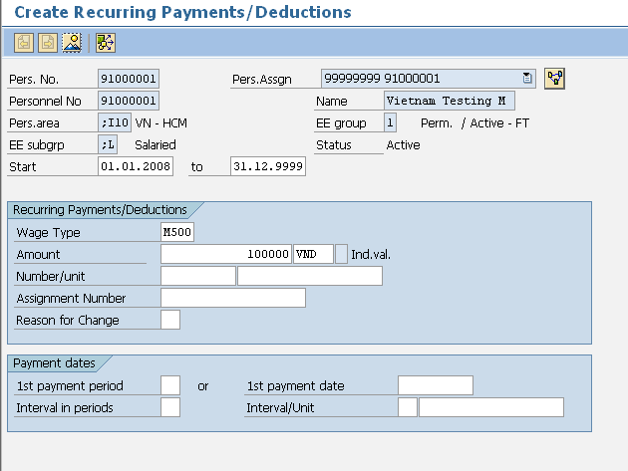

These are the mandatory fields. Note that you cannot enter both an amount and a number/unit. This will depend on how the wagetype is setup.

**Description**: Infotype 0014 stores the recurring allowances and deductions that are not included in the salary package; these wage types are permanent and paid monthly. Important Fields are:

**Permanent Allowances/Deductions - Infotype 0014:**

* Wage Type
* Amount
* Number/Unit
* Currency
* Start and End Dates (end date must be 31.12.9999)

### IT0015

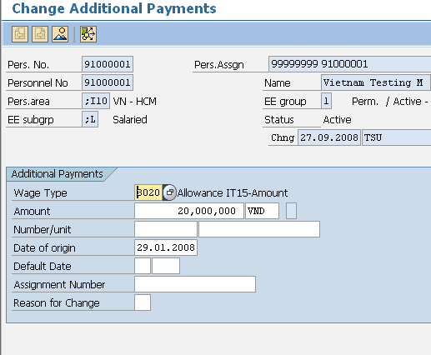

These are the mandatory fields. Note that you cannot enter both an amount and a number/unit. This will depend on how the wagetype is setup.

**Description:** Infotype 0015 is used for one off payments; these are known as ad-hoc payments. Important Fields are:

**Additional Payments – Infotype 0015:**

* Wage Type
* Amount
* Number/Unit
* Currency
* Date of Origin (Start and End Dates in the spreadsheet must be the same)

## Family Member / Dependents - Infotype 0021

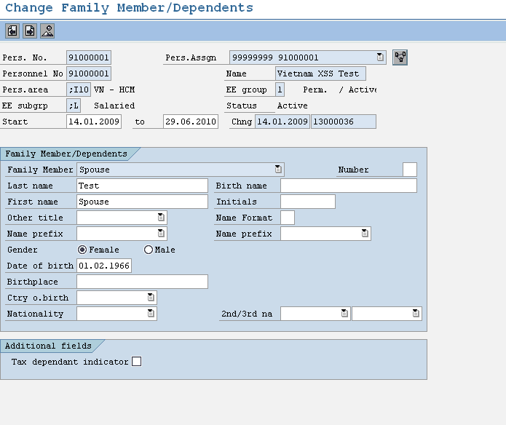

**Description:** Infotype 0021 is used for family member or dependents details

**Family Member / Dependents – Infotype 0021:**

* Family Member Type
* First Name
* Last name
* Gender
* Date of birth
* Birthplace
* Tax dependant indicator (to indicate the member is tax dependant or not and create link to IT9522)

## Personal ID - Infotype 0105 <Mandatory Infotype>

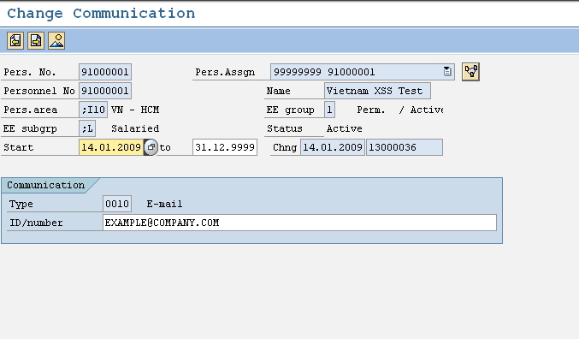

**Description:** Infotype 0105 is used to store employee email address

**Communication – Infotype 0105:**

* Type 0010
* ID number for email address

## Personal ID - Infotype 0185 <Mandatory Infotype>

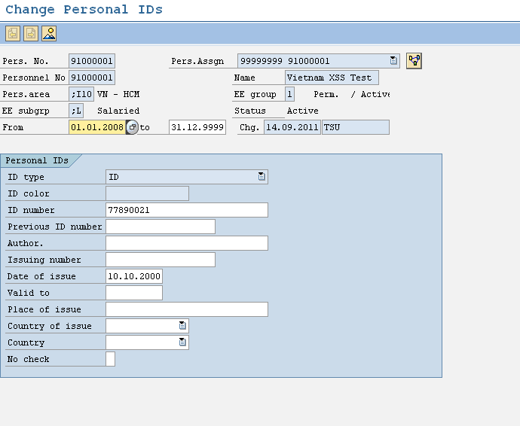

**Description:** Infotype 0185 is used to store employee Personal ID issue date

**Personal ID – Infotype 0185:**

* ID number (default from IT0002)
* Date of issue
* Place of issue

## Absence Quotas - Infotype 2006

All you need to supply when loading absence quotas is the quota type, start and end date. The balances are loaded later.

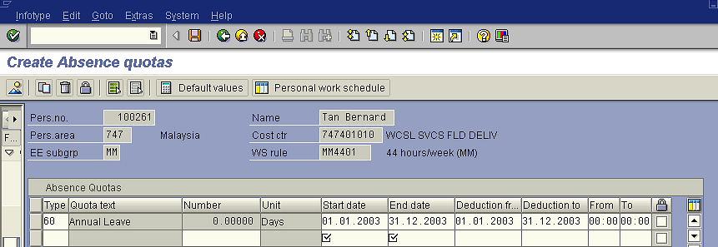

**Description:** In SAP leave is recorded as an absence. Some absences are linked to leave quotas that hold the entitlement and pro-rata values. These leave types are annual leave, sick leave and long service leave etc. When employees are hired a record is created for annual leave, sick leave and long service leave but no quotas are loaded at this point, they are left blank. Infotype 2006 loads the following information:

**Absence Quotas – Infotype 2006:**

* Start and End/To Dates
* Leave Type (e.g. Annual = 60, Sick = 70, subtypes may vary depending on the client)

## Quota Corrections - Infotype 2013

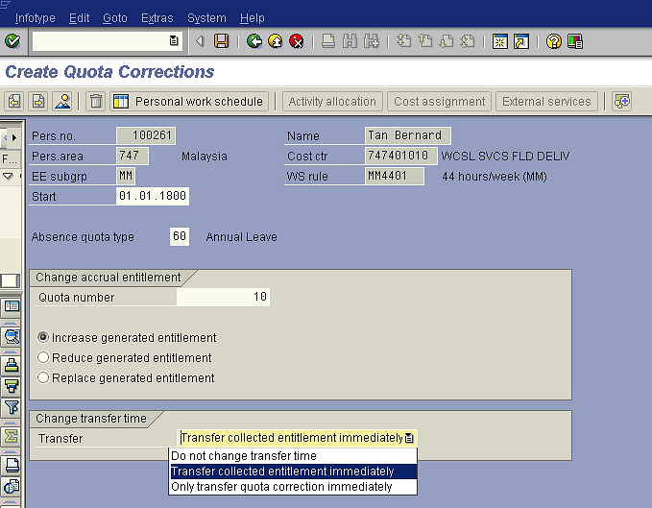

An entry must be made in all these fields. The most common options are shown. If you wish the entitlement only to be transferred on anniversary you would select “Do not change transfer time”

**Description:** Infotype 2013 allows you to increase, reduce or replace leave balances for the appropriate leave type. Therefore when you have loaded an IT2006 for each employee for each leave type that they are entitled to you can use this infotype to load the existing balances into IT2006. Quota Corrections (IT2013) loads the following fields:

**Quota Corrections – Infotype 2013:**

* From and To Dates must be the same
* Quota Type
* Quota Number
* Increasing, Reducing, or Replacing Leave Balance
* Transfer Time

## Absences - Infotype 2001

Infotype 2001 is NOT required for the initial data load!

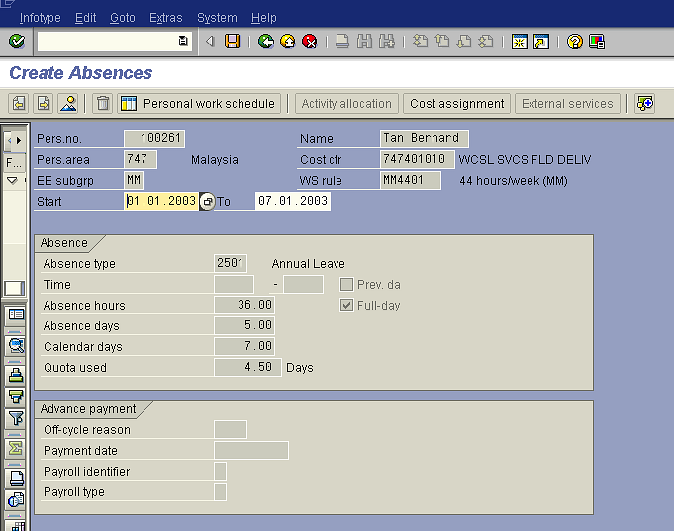

These items are actually entered in the front screen when entered manually. The calendar days default from the start and end dates entered. When loading by spreadsheet you should also only enter the start and end dates. Again the days will default.

**Description:** This data load sheet loads employee leave entries. However in reality you will rarely need to load leave entries. It is either done by the payroll team or through ESS on an ad hoc basis.

Infotype 2001 holds the following information:

**Leave – Infotype 2001:**

* Start and end Dates
* Wage Type
* Start and End Times/Absence Hours (only enter if less than one day’s leave is being applied for)

## Employee Remuneration Information - Infotype 2010

Infotype 2001 is NOT required for the initial data load!

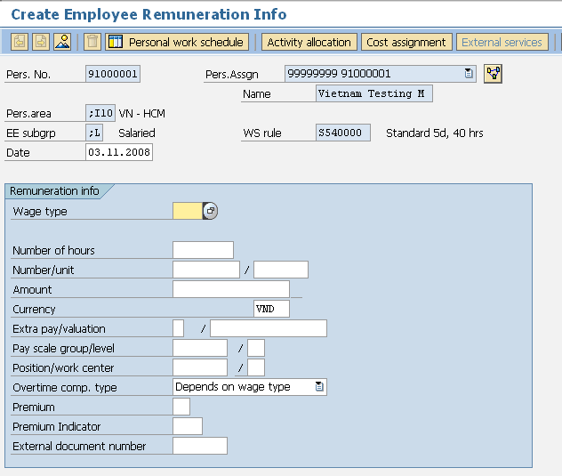

These fields are rarely used but can be utilized if necessary

These are the mandatory fields. Note that you will either use hours, number unit or amount, not a combination. This will depend on the wagetype and how it works

Alternative cost centres can be entered here

**Description:** This is used to input time sheet entries such as overtime and meal allowances. However this is sometimes done via ESS or manually by the payroll team. Important fields’ infotype 2010 loads are:

**Employee Remuneration Information – Infotype 2010:**

* Start and end Dates
* Wage Type
* Amount/Hours
* Note that in the spreadsheet there is a field for Cost centre so that a payment can be assigned to a different cost centre. To do this manually you would click on the cost assignment button.

# Country Specific Infotypes

## Change Personal Income Tax - Infotype 9520 <Mandatory Infotype>

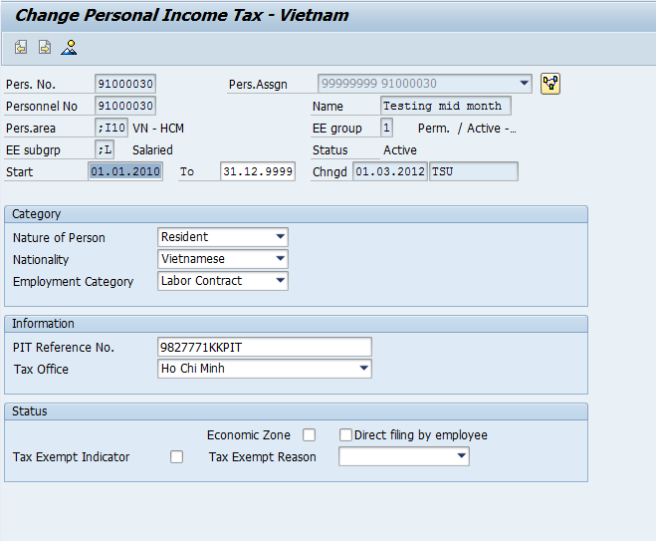

**Description:** This is used to store the employee’s tax declaration details. Key fields in infotype 9520 are:

* Nature of Person (Resident/Non-resident)
* Nationality
* Employment Category
* Employee PIT Reference Number
* Tax Office location
* Economic Zone
* Direct filling by employee (fill in tax finalization month period)
* Tax Exempt Indicator
* Tax Exempt Reason

## Change Social Insurance Vietnam - Infotype 9521 <Mandatory Infotype>

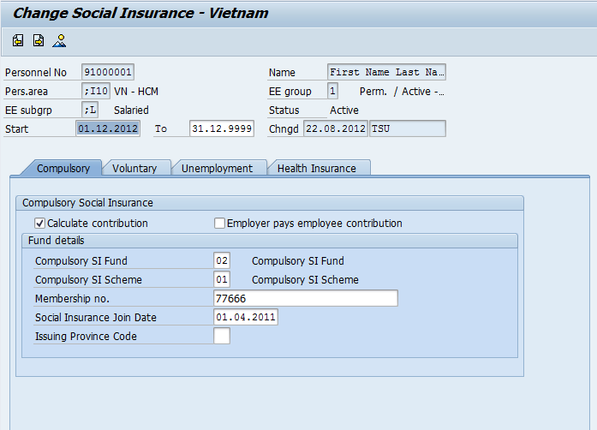

**Description:** This is used to store Employee’s Social Insurance details and applicable insurance types. Key fields in infotype 9521 are:

### Compulsory Insurance

* Calculate contribution
* Employer pays employee contribution
* Compulsory SI Fund
* Compulsory SI Scheme
* Membership no
* Social Insurance Join Date (use validate the SI new participate)
* Issuing Province Code (use in A01a-TS report)

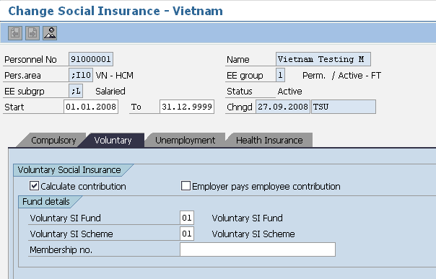

### Voluntary Insurance

* Calculate contribution
* Employer pays employee contribution
* Voluntary SI Fund
* Voluntary SI Scheme
* Membership no

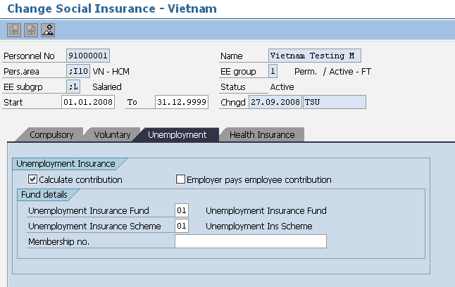

### Unemployment Insurance

* Calculate contribution
* Employer pays employee contribution
* Unemployment Insurance Fund
* Unemployment Insurance Scheme
* Membership no

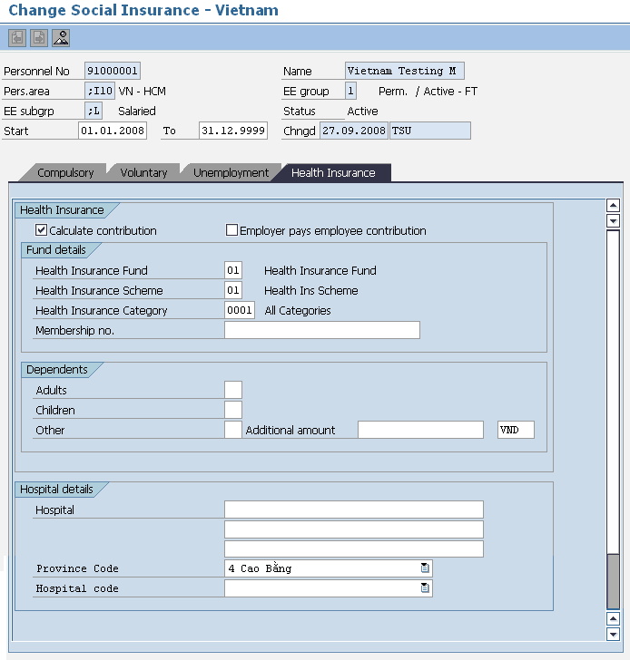

### Health Insurance

* Health Insurance Fund contribution
* Health Insurance Scheme
* Health Insurance Category
* Membership no
* Dependents
* Hospital Details
* Province Code (use on SI report)
* Hospital Code (use on SI report)

## Annual Values for Tax and Reporting - Infotype 9524

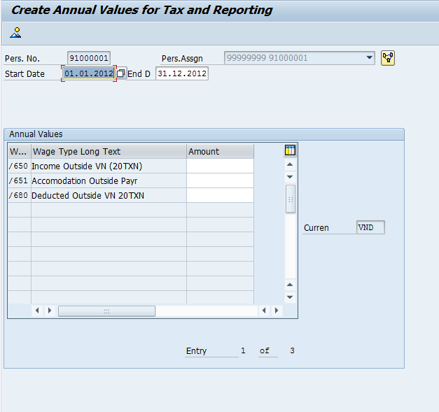

**Description:** This is used to input data print on form 20TXN under section 4, 5 and 6

**Annual values for Tax Reporting – Infotype 9524:**

* /650 Income Outside VN (20TXN)
* /651 Accommodation Outside Payroll
* /Deducted Outside VN 20TXN

# Appendix

### ADP Reference Documents

| **ADP GV Document ID** | **Description** | **Document** |
| --- | --- | --- |
| GV00002671 | G2 SSL Data Entry |  |
| GV00009265 | Data Load with the ADP SSL Interface |  |
| [A-PMS0008](https://portal221.globalview.adp.com/irj/servlet/prt/portal/prtroot/com.sap.km.cm.navigation/room_extensions/cm_stores/ADP_Project_Documents/workspaces/e022f269-0f29-3610-d894-aa1cc65e30ca/C.%20Interfaces/Functional%20Specs?StartUri=/room_extensions/cm_stores/ADP_Project_Documents/workspaces/e022f269-0f29-3610-d894-aa1cc65e30ca) | RMIT AU G2 Specification | [Project cRoom](https://portal221.globalview.adp.com/irj/portal?NavigationTarget=CollaborationConnector://portal_content/com.sap.ip.collaboration/Rooms/0097866c-6880-3710-8ea2-f285dc4b04cd/workset) |
|  | RMIT VN Blueprint Configuration Worksheet | Project cRoom |
|  | RMIT VN ADP GV - Payroll Business Blueprint | Project cRoom |
|  | RMIT VN ADP GV - Time Business Blueprint |  |
| [GV00003434](https://portal221.globalview.adp.com/irj/servlet/prt/portal/prtroot/com.sap.km.cm.navigation/room_extensions/cm_stores/ADP_Global_Project_Documents/workspaces/20c39902-a9a6-3510-10b1-a2ce70767711/2-Global%20Design%20(GTD%2cxSS%2cGTD)/GTD/GTD%20Final%20versions?StartUri=/room_extensions/cm_stores/ADP_Global_Project_Documents/workspaces/20c39902-a9a6-3510-10b1-a2ce70767711) | RMIT Global Template Document | [Project cRoom](https://portal221.globalview.adp.com/irj/portal?NavigationTarget=CollaborationConnector://portal_content/com.sap.ip.collaboration/Rooms/0097866c-6880-3710-8ea2-f285dc4b04cd/workset) |
|  | RMIT_Global_Vs_local_Infotypes |  |
| - | SSL Template | Project cRoom |
| - | Template – YTD Data Example |  |